Senior Staff Bios

Louise Calixte, Chief Program Officer, Permanent Supportive Housing

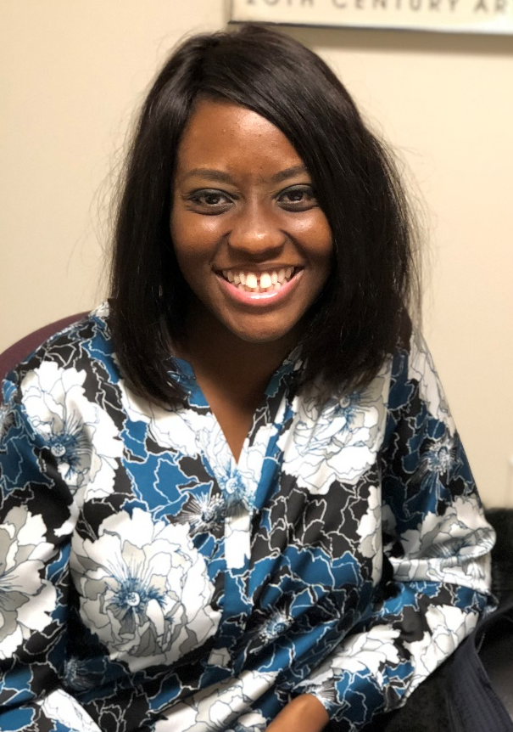
Louise B. Calixte is the Chief Program Officer of Permanent Supportive Housing at Inspirica. Louise was initially brought on board as the Director of the Family Emergency Shelter in 2014. She eventually became the Director of the Family Housing Program, which includes responsibility for the oversight and daily management of the emergency shelter as well as the transitional housing program. Currently, Louise oversees Inspirica’s Permanent Supportive Housing Program, which includes Atlantic Park Apartments, Colony Apartments, 24 and 26 Woodland Place Apartments, 992 Summer Place Apartments, Metcalf, and Rose Park Apartments.

Louise has an undergraduate degree in Psychology and Criminal Justice from Temple University in Philadelphia, PA. Louise continued her studies at the State University of New York at Buffalo Law School where she earned her Juris Doctorate. Prior to Inspirica, Ms. Calixte was a Family Life Advocate/Stabilization Specialist at the Families-In-Transition Program in association with the YMCA in Boston, MA.

